CHARACTERISTICS OF ABUSED WOMEN WHO VISITED IN MASONWABISANE WOMEN SUPPORT IN EASTERN CAPE.

By: SIZEKA MONAKALI

RESEARCH DISSERTATION

Submitted in fulfilment of the requirement for the degree of

MASTER OF PUBLIC HEALTH

FACULTY OF HEALTH SCIENCES

(National School of Public Health)

at the

UNIVERSITY OF LIMPOPO (MEDUNSA CAMPUS)

SUPERVISOR: Ms MATHILDA MOKGATLE – NTHABU

C0-SUPERVISOR: Dr. OLUWAFEMI O. OGUNTIBEJU

DECLARATION

I hereby declare that the Characteristics of abused women in Masonwabisane Women Support Centre in Eastern Cape (mini-dissertation / dissertation / thesis) submitted to the University of Limpopo, for the degree of Master of Public Health (MPH) (the degree & field of research) has not been previously submitted by me for a degree at this or any other university; that is my work in design and in execution, and that all material contained herein have been duly acknowledged.

S. Monakali (Mrs)
_________________ ______________
Initials & Surname Date
Student Number: 200587552

DEDICATION

I dedicate this study to Ms J.N. Mda for giving me support throughout my studies and Mrs.Yoliswa Mathole for support and encouragement and taking care of my kids during tough times of having no helper. Enkosi Madlamini. I dedicate this study also to Monakali family for support and encouragement and Songca family in Tsolo for instilling the love of education at an early age. Also to all educational institutions I have attended, Dumrana Junior Secondary School Umthatha ), Gcisa Senior Secondary School (Tsolo), Butterworth Hospital (Butterworth), University of South Africa (Pretoria), University of Kwazulu Natal (Durban), and University of Limpopo Medunsa Campus (Pretoria). Indeed I dedicate this study to everyone who has contributed in making me, who I am today, Butterworth Hospital staff and my colleagues at East London Campus – Butterworth Satellite Campus. My friends in embanet, Tobeka Lebenya and Zolisa Swartbooi - Xabadiya, you are everything to me.

ACKNOWLEDGEMENT

I acknowledge God for giving me wisdom, strength and inspiration for completing this study.
My late father Lethile Kupiso and my mother Nongenile Kupiso for support and encouragement thanks Bhelekazi.

Zolani Monakali, my husband for the unconditional love and continuous support. Enkosi Hlubi. I acknowledged my kids Songezo, Indiphile, Bhungane and Wandile for being my inspiration and powering my desire and strength.

I also acknowledged the financial support I received from Medical Education for South African Blacks (MESAB). The contributions from this organization were invaluable.

My sincere appreciation to the following people and organizations that made this research possible:

- Ms Sphiwe Madiba for support and guidance with RMPH 701.
- Ms Mathilda Mokgatle – Nthabu for her invaluable assistance and constructive guidance.
- Masonwabisane women support centre, Amathole district manager and the Epidemiological research and surveillance management directorate, Eastern Cape Department of health for giving me permission to conduct the study.
- Mgomanzi Senior Secondary School for giving me permission to conduct community service as required by MESAB.
- Noziphiwo Mbadamana research assistant for all her work and dedication towards this study and for her precision, quality work and honesty in collecting data.
- Ms Mzikazi Nduna for giving up all her time to offer assistance when ever I called for it.

ABSTRACT

Background
Despite of all the media information and reports about women abuse and non- reporting, there seems to be a high rate of domestic violence, according to reports obtained at Masonwabisane women support centre in Butterworth, Eastern Cape. According to the managing director of the above centre twenty (20) victims report daily at the centre. Probably because of cultural and religious beliefs, violence is not always reported or talked about. It is against this background that the researcher intended to conduct this study.

Aims
Examination of the characteristics of abused women who visited Masonwabisane Women Support Centre (MWSC) in Butterworth, Eastern Cape.

Methodology
Data was collected at MWSC in Butterworth an NGO operating under Mnquma local municipality. A descriptive quantitative study was used on records of abused women obtained from Butterworth areas who visited the centre and were reviewed retrospectively using a template developed by the researcher with effect from the 1st of July to 31 December 2007. The records were divided according to the areas served by the organization and the sub-samples randomly selected from each area. The analysis was based on the information that was generated from the questionnaires that women who visited the centre provided.

Results
The study indicated that the majority of the participants (94 %) were below the age of 40 years. Among the abused women 49 % were single. Almost all the women were living in the rural, informal settlement or township areas. Only ten (4 %) of the cases had no formal education while close to 82 % had at most a secondary school education and the rest 14.3 % had tertiary education. About 24 % of the cases were unemployed and 26.9 % were students. This gives a total of close to 50 % of cases who are economically inactive. The rest of the respondents were either in full time (15.1 %) and in part time (33.9 %) employment. At the time of presentation at the centre, two third (75 %) were traumatized 24 % injured, 13 % confused while 8.6 % were reserved and 2.9 % not well groomed. Over half (55.5 %) of the abuse cases were emotional abused, followed by physical abuse at 31 % while sexual abuse were 7.3 % and economical abuse were 6.1 %. Over a quarter (33, 5%) of women used tobacco, 10, 2% used alcohol and 3,3 % used illicit drug while over half (53,1%) of women did not use any from of substances. At the time of presentation at the centre the following personality traits from abused women were observed, almost half (44 %) of the abused women were angry, 26 % were stubborn and 15% were submissive while 14 % were aggressive. Majority of women (80 %) reported abuse during the week. One tenth (12 %) of women were abused during their pregnancy and 25% during their menstrual period. Because of the abuse almost a quarter (24 %) were physically disabled. Two thirds (66 %) of the women had children between 1 and 4 were abused. Majority (80 %) of women were abused by their husband or partners.

Results show that employment and obstetric status were significantly associated (Χ² = 96.24, p < 0.001). Type of abuse was not dependent on any other variables in the study. Frequency of reporting was associated with type of substance uses (Χ² = 18.94, p = 0.04) and relationship with perpetrator (Χ² = 94.78, p < 0.001). Occupation of the perpetrator was related to obstetric status (Χ² = 193.58, p < 0.001), disability (Χ² = 34.51, p < 0.001) and no of children the women had (Χ² = 116.23, p < 0.001).

Conclusion
The following characteristics were observed from women who visited MWSC women support centre Butterworth, most women between 20-29 years of age were single they were either having steady relationships co-habiting. Most of them were staying in partner’s house or flat. Most of them came from townships and were economically inactive. It was evident from data analysis that most of them had low level of education (82 % secondary education) and they struggle to get employment. Another characteristic was that 66 % of cases were still students and therefore depended on their partners for financial support, which in some cases were elderly men. Most of them presented traumatized at the centre and the common form of abuse experienced was emotional abuse. Most of the abused women were found angry. To some extent others were so abused that they got injuries that led to their physical disability e.g. fractures. Most of them reported abuse at the centre during the weekdays and working hours. This could have an impact on statistics of women abuse as some women are abused by their partners or husbands during the night or weekend, some of them may feel it is no longer necessary to report abuse the following day or following week.

Key words: Domestic violence, Characteristics of abused women, patterns of reporting.

ACRONYMS

AIDS Acquired Immune Deficiency Syndrome

BWT Butterworth

DOH Department of Health

HIV Human Immunodeficiency Virus

IDP Integrated Development Plan

MSWC Masonwabisane women support centre

MEDUNSA Medical University of South Africa

MESAB Medical Education for South African Blacks

NCADV National coalition against domestic violence

NGO Non Governmental Organization

REC Research ethics committee

RMPH Research Methodology in Public Health

STI Sexually Transmitted infections

VAW Violence against women

WHO World Health Organization

UNITRA University of Transkei

DECLARATION 2
DEDICATION 3
ACKNOWLEDGEMENT 4
ABSTRACT 5
Background 5
Aims 5
Methodology 5
Results 5
Conclusion 6
ACRONYMS 7
CHAPTER ONE 11
1.1. INTRODUCTION 11
1.2. Background of Masonwabisane Women Support Centre 12
1.3. RESEARCH QUESTIONS 15
1.4. STUDY AIM 15
1.5. STUDY OBJECTIVES 16
1.6. JUSTIFICATION 16
CHAPTER TWO 17
2.1. LITERATURE REVIEW 17
2.1.1. INTRODUCTION 17
2.1. Types of abuse experienced by women in situation of domestic violence 17
2.1.2. Characteristics Expressed by Women who have experienced domestic violence. 18
2.1.3. What women can do when experiencing domestic violence 22
2.1.4. Means of assistance available to abused women in the community 25
CHAPTER THREE 27
3.1. METHODOLOGY 27
3.1.1. INTRODUCTION 27
3.1.2. THE STUDY DESIGN 27
3.1.3. STUDY POPULATION 27
3.1.4. STUDY SETTING 27
3.1.5. SAMPLING PROCEDURE 28
3.1.6. DATA SOURCES 28
3.1.7. ETHICAL CONSIDERATION 28
3.1.8. DATA COLLECTION TOOLS 29
3.1.9. DATA COLLECTION 29
3.1.10. DATA RELIABITY 30
3.1.11. DATA VALIDITY 30
3.1.12. DATA ANALYSIS 30
3.1.13. LIMITATIONS OF THE STUDY 30
CHAPTER FOUR 31
4.1. RESEARCH RESULTS 31
4.1. 1. Introduction 31
4.1.2. General Descriptive Findings of the Results 31
4.1.3. Age distribution of abused women 32
4.1.4. Marital status of abuse women 33
4.1.4. Place of residence 33
4.1.5. Educational level of abused women 34
4.1.6. Employment status of the study sample 35
4.1.7. Clinical Conditions and Characteristics 35
4.1.8. Distribution of the Type of Abuse among the Women 36
4.1.9. Substance Abuse 37
4.1.10. Personality Traits of the Abused Women 38
4.1.11. Number of times women reported their Abuse 38
4.1.12. Time of reporting abuse by the study sample 39
4.1.12. Time of Reporting 40
4.1.13. Obstetric Condition of the Women during Abuse 40
4.1.14. Distribution of Disability of Women by Abuse 41
4.1.15. No Children had Among Abused 42
4.1.14. Relationship between women and their Perpetrator 43
4.1.15. Distribution of the Occupation of the Perpetrator 44
CHAPTER FIVE 46
DISCUSSION, CONCLUSION AND RECOMMENDATIONS 46
5.1. INTRODUCTION 46
5.4. Recommendations 50
5.5. Conclusion 51
References 53

CHAPTER ONE

1.1. INTRODUCTION

Every twelve seconds in South Africa a woman is a victim of domestic battery (Bohn, 1990). Battered women are defined as women who have suffered one or more episodes of battery from their male partners or ex- partner. Battery includes slapping, kicking, punching shoving, torture and sexual assault. Women who are physically abused also suffer psychological and emotional battery (Bohn, 1990).

World Health Organization, WHO (2004) defined intimate partner violence as “the range of sexually, psychologically and physically coercive acts used against adult and adolescent women by current or former male partner”. Intimate partner violence is of great concern because it is global, violates fundamental human rights of women, and is a major public health problem. There is no racial, ethnic or socio- economic predictor of abuse, all women are at risk of being abused. An overwhelming 50 % of all women will experience physical violence in an intimate relationship (Bohn, 1990). Women in rural areas may be at increased risk due to social isolation, and cultural traditions and lack of resources which inhibit reporting of domestic violence (Talk Show Unitra Community Radio March, 2007).

.
Domestic violence is one of the most pressing social problems in the world with the statistics increasing day by day in Southern African countries (David, 1990). A study of 10 countries found that between 13 and 62 percent of women have experience physical abuse by a partner over the course of their life time and between 3 and 29 percent of women reported violence with the past year (Bott, Morrison and Ellisberg, 2005). Internationally 8-26 percent of women and girls reported having been sexually abused as children or adult. An estimated one of every three women globally is beaten, raped or otherwise abused during her lifetime (Ellisberg, et al; 1999; Heise, 1999). A recent study in South Africa (SA) found that a woman is murdered by an intimate partner every six hours. (Mathew 1996; Abraham 2000).

Research evidence shows that women who experience domestic violence tend to suffer psychological effects such as low self esteem, depression and post traumatic stress disorder (Renvoize, 2002). According to Hutchingss (1998) domestic violence is the infliction of physical pain brought about slaps, punching, biting and hair pulling. Abused women are not living the same life as non- abused women (Buzawa and Buzawa, 2002).

Renvoize (2002) believes that there are high numbers of women who are abused by their husband or spouses and these women continue to think that situation will improve and do not report this to officials. Kirkwood (2000) argues that battered women tend to be autistic. Loneliness has been observed from battered women all over the world. Some women are lacking knowledge about abuse, meaning they do not know by being violated are abused. Kleint (2000) believes that women who have experience violence tend to be disturbed emotionally.

According to Roy (1999) women who have children claim that their partners abuse them and tend to extend the violence to their children. These women indicate that one particular child is more likely to be a victim of violence abused. Some women claim that their husband’s violence behaviour had made them to become hesitant in having more children and the issue of birth control receives much more consideration. The family which is characterised by violence will produce emotional unstable children (Kalmuss, 1984; Seltzer and Kalmuss, 1988).

.
There are about twenty victims of domestic violence who reported to the Masonwabisane centre daily (personal communication with Mrs. Mokoena), Managing Director Masonwabisane Women Support Centre). It is against this background that the researcher intends to conduct the study.

1.2. Background of Masonwabisane Women Support Centre

Masonwabisane women support centre is an NGO located in Butterworth. Butterworth is a small town under Amathole district situated in Mnquma local municipality. According to the community survey of 2007 Mnquma municipality has a total population of approximately 297 663 people, 99% of which are Xhosa speaking; the remaining 1% of the population includes English, Afrikaans, Zulu, and Sesotho speaking people. This female dominated Municipality comprises 54% female and 46% male of the total population and consists of approximately 75 410 house holds. Age distribution revealed that the bulk of the population approximately 53% is children (0-19 years). About 6.3% falls within the pension group (over 56 years), whilst 38 .5% is economically active (20-64 years). This indicates that there is high dependency rate ratio, as 59% of the population depends on only 41% workforce in the municipality. As part of the Eastern Cape Province Mnquma is one of the municipalities with the highest of poverty, illiteracy and unemployment. (Integrated Development Plan 2009/2010 (p.4) Butterworth: Mnquma local municipality.

Masonwabisane Women Support Centre is an organization established in 1997 and registered as a non- governmental organization (NGO) based in Butterworth. This centre was established to serve the interest of the poor rural areas of Butterworth which consists of the following areas:

- Three Suburbs
- Seven Townships
- Eight informal Settlements
- Twenty five rural areas (Mnquma local municipality map imagery date April 24 - -June 30, 2003).

The mission of this organization is to:

Provide support to abused women and children in a manner that restores dignity, ensure respects and affirm right and responsibility at home and within historically disadvantaged communities.

Masonwabisane provides direct and indirect support services for integrated and greater productivity indicative of holistic development

The illustration below shows the areas of Mnquma local municipality (Butterworth) served by MSWC (Mnquma local municipality map imagery date April 24 - -June 30, 2003)

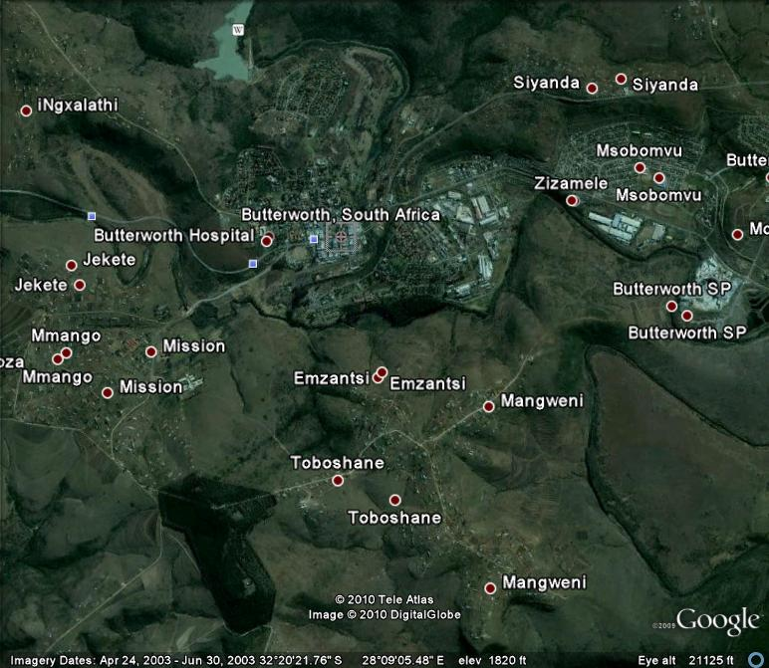

1.3. RESEARCH QUESTIONS

- What types of abuse are commonly experienced by clients of MSWC?
- What are the patterns of abuse reported at the women support centre?

1.4. STUDY AIM

The aim of this study was to examine the characteristics of abused women who visited
Masonwabisane women support centre in Butterworth.

1.5. STUDY OBJECTIVES

- To identify types of abuse commonly experienced.
- To determine the pattern of abuse reported at the women support centre.

1.6. JUSTIFICATION

Finding out the specific forms of abuse experienced by women in situations of domestic environment will help abused women to be aware of such forms of abuse. Identifying the various emotions expressed by women who have experienced domestic violence will raise awareness of such behaviours. Determining what women do when experiencing domestic violence will help those women who are reluctant to report domestic violence take actions themselves. Sharing the experiences that helped abused women to emerge out of the abusive relationships would help raise awareness to other women who find themselves in the same predicament. Enquiring about services available to assist abused women will help raise awareness to other abused women who find in their communities.

CHAPTER TWO

2.1. LITERATURE REVIEW

2.1.1. INTRODUCTION

This literature will deal with a summary of knowledge about women abuse gathered from academic literature relevant to this study. Research studies that have contributed to the field in manner similar to my own dissertation are cited. Literature about types of abused experienced by women in situation of domestic violence, characteristics expressed by women who experienced domestic violence and strategies that abused women have used to help themselves.

2.1. Types of abuse experienced by women in situation of domestic violence

Physical abuse

According to Koos and Goodman (1994) physical violence and its threat are ugly and means of securing control or dominance. It is almost certain that violence is multi- dimensional that is, a violent episode is caused by a combination of factors rather than any single factor operating in isolation, and for example man who believes strongly that the man should be the head of the household will be threatened by loss of work, particularly if the wife is employed. The link between alcohol and spouse abuse is rather firmly established in the minds of the general public and individual who frequently report violent episodes occurring while have been drinking. The implication of direct causal relationship is often made however the precise nature of this relation must be carefully considered (Koos and Goodman, 1994).

Sexual abuse

According to the national coalition against domestic violence (NCADV, 1989) reports, sexual abuse is common in abusive relationships. According to these reports one third and one half of all battered women are raped by their partners at least once during their relationship. Any situation in which force is used to obtain participation in unwanted, unsafe, or degrading sexual activity constitutes sexual abuse. Forced sex even by spouse or intimate partner with who consensual sex occurred is an act of aggression and violence. Further more women whose partners abuse them physically and sexually are at high risk of being seriously injured or killed (NCADV, 1989)

Emotional

Friedman (2003) states that emotional abuse is the most severe one but yet unnoticed violence; the abusers make the victim to feel worthless. They isolate them from friends and family. Then they want to take full control of the victim’s lives. They make these women feel guilty and blame themselves for the wrong they did then play with their emotions to do whatever the abuser wants.

2.1.2. Characteristics Expressed by Women who have experienced domestic violence.

Age
A woman’s age is thought to affect the likelihood that she will experience domestic violence. Researchers argues that as a woman ages, she often grows in social status as she becomes not only a wife, but a mother, and perhaps a more economically productive or socially influential member of her community, thus older women are less likely to report current experience of abuse than young women Fermandez, 1997; McClusk, 2001).

General Health Conditions

Violence against women (VAW) has a serious consequences for women’s health and well being ranging from fatal outcomes such as homicide, suicide, and AIDS related deaths to non–fatal outcomes such as physical injuries, chronic pain, syndrome gastro-intestinal disorders, gynaecological problems, unwanted pregnancy, miscarriages, low birth weight of children and sexual dysfunction (Bott, Morrison & Ellsberg, 2005). The World Bank estimates that at global level, the damage and costs to health from violence against women aged 15-44 years is comparable to that posed by other risk factors and diseases such as AIDS.

According to World Health Organisation (WHO, 2004) multi-country study on women’s health and domestic violence against women, women who have experienced violence by a partner have:

- Worse general health
- More symptoms of ill health such as pain and bad memories
- More suicidal thoughts and attempts
- More induced abortion and miscarriages.

Several review of relevant literature (Heise et al., 1999; Campbell, 2002) emphasizes the linkage between the experience of domestic violence and both fatal and nonfatal outcomes for women and their children. Fatal outcome related to domestic violence for women can result directly through homicide or indirectly through suicide and maternal or AIDS related mortality. Non fatal outcomes include manifestations of mental, physical, and reproductive health outcomes, and negative health behaviours (Heise et al., 1999).

Poor physical health among abused women manifests as chronic conditions including chronic pains, injuries, gastrointestinal disorders and generally poor health status among others. Abused women’s reproductive health is also compromised through much high rates of gynaecological problems, HIV, sexually transmitted infections (STIs), miscarriages, abortions, unwanted pregnancy and low birth weight (Campbell 2002). Negative health behaviours include overeating, alcohol and drug abuse sexual risk taking. Although the pathways from maternal experience of violence to health and survival of children are not well understood, research evidence provides of increased mortality and under nutrition among children of abused mothers (Jejeebhoy, 1998; Ganatrage, et al., 1998, Asling – Monemi et al., 2003).

Socio – economic status

The social and economic costs of violence against women are enormous and have ripple effect throughout society. Women may suffer isolation, inability to work, loss of wages, lack of participation in regular activities, and inability to care for themselves and their children (WHO, 2004).

Education has shown to be a source of empowerment for women facilitating their ability to “gather and assimilate information, manipulate and control the modern world and interact effectively with modern institutions” (Kishor, 2000; Malhotra and Mather, 1997). It hypothesize that women with higher education have greater resources to draw upon in times of need, such as when dealing with a violent partner, hence women with higher education experience less violence.

Status inconsistency theories see violence as resulting from resource imbalance among family members where resources include both material and non-material (such as education and prestige, etc) assets. Patriarchal norms typically imply that men will have more resources than women, and the empowerment of women can upset this balance Women can experience violence when patriarchal norms are threatened by resource imbalance in favor of women, which over time can generate stressors with the family (Gelles, 1993).

Similar to education, women who are engaged in paid employment are hypothesized to have more say over financial and other household matters than women who are not active in the labor market (Malhotra and Mather, 1997).

Number of children

Several studies indicate that the risk of experiencing violence is positively associated with women’s number of children (Ellisberg, 2000; Martin et al., 1999). The relationship between violence and the number of children a woman has borne can be conceptualized such that when there are more children in the household, there is less income per capita, insufficient resources may lead to exacerbated level of stress for the head of the household, which may lead to violence in some instances, hence the more the children the greater the likelihood of violence (Martin et al., 1999). According to multi- country domestic violence study, results showed that women with no children have the lowest rates of ever – experience of violence, and in most countries women with five or more children have the highest of ever – experience of violence.

Family Circumstances

Intergenerational effect

Research has documented an important negative effect of domestic violence on children, even if the children are not themselves abused: male children who see their mother being abused by their father are at risk of becoming abusers in their intimate relationships as adult (Kalmuss, 1984; Seltzer and Kalmuss, 1988).

Psychological Factors

According to Morrison and Hines (1998) guilt and shame are the most common emotions in the abused women. These women tend to blame themselves for the abuse. This guilt often intensified with time as the abused women gain a clear understanding of domestic violence; Flitcraft and Stark (1999) argue that anxiety is another effective response of domestic violence. This anxiety can be manifested in various ways in both short and long term depending on the duration of domestic violence. Reid (2002) believes that abused women also experience extreme level of fear. These fears tend to restrict and control the victim’s life. These abused women tend to isolate themselves from people, who can help them, believing that what is happening to them they deserve it. Manor (1997) sees depression as an effect and a frequent reaction to the domestic violence. The current abuses will almost invariable result on an ongoing depressive state. Gillespie and Lupton (2002) argue that some of these women decide to end their lives because they cannot go on living like that that is they cannot stand the pain of being abused day in and day out. Barnett and Parrin (2005) believe that these abused women try to please their husbands in every way they can think of. According to Johan (1994) abused women tend to suffer from borderline personality disorder, whereby the individual become dependent on others instability mood, avoid having interpersonal relationship affective instability marked by shift from baseline to depressive irritability or having an anxiety.

Dulton (1992) believes that anger is most common to the abused women. Anger is commonly directed to the husband or boyfriend. This anger is prolonged and in some cases may be directed to the society, police or family members for not helping or try to see when the victim is crying for help. He further argues that abused women fear that if they decide to leave their abusive husbands they may threaten to take away children. These women tend to isolate themselves as they feel helpless and inadequate.

According to Viano (1992), the wife that is abused is always ashamed, embarrassed and angry about what is happening to her. Dobash and Dobash (1992) believe that women who have experience domestic violence may suffer from high blood pressure, because of anxiety and instability associated with the abuse at home. Taylor and Stewart (2002) argue that violence can cause them to be poor mothers who are unable to take care of their families in the long run. When violence is perpetrated by a partner, a person who has been in a relationship of trust by the victim, it can lead to a feeling of confusion and even thinking of committing suicide or even killing the partner.

2.1.3. What women can do when experiencing domestic violence

According to Johan (1994) most abused women are reluctant to report the abuse to the prosecutor and other professionals who are trying to help them and end the abuse because they love the man. This may sound strange to people who are not experiencing this love. Perhaps in some cases it is almost like obsessive compulsive live interest, in which the fear of losing the man is much more frightening than the abuse to which one has become conditioned. The abused women know that this kind of thinking is not logical, yet victims of domestic violence tend to think this way. Until the abuse tends to get so severe or so frightening or so threatening that the victim realizes she had to end it or risk of losing her life or killing the abuser. According to Manor (1999) the only foolish part is for the victim of abuse to think that the abuse will end some sort of steps being taken to reform the abusers attitude and behaviour. Dobash and Dobash (1992) believes that the fear of loneliness, the belief that one is unable to help oneself, the dependency on the abuser and the fear of being rejected is so overwhelming that even the abuse seem tolerable. Victims of abuse think about many times when their abusive males were affectionate, loving and caring. These good times get so elevated in their memories and the bad times get buried deep within their subconscious minds. Such thinking enables the abused women to continue to tolerate the abuse without even thinking of reporting the abuse to the police. Ending the relationship may sound like impossible task. Sometimes it comes about as part of the progression of the bad relationship. In other words for how long psychologically and emotionally, can make the person feel affection towards the man that has battered, ridicule isolated verbally attacked and destroy ones’ soul. Renvoize (2002) states that abused women can do something for themselves like leaving the abusers and take control of their lives. A victim may suddenly realize that her abusive man does not love her. While this is devastating it is part of the process of recognizing that the relationship is on the skids and is to sink unless effective measure is done to repair it. Maybe ending the love will result from a victim’s exposing herself to various help groups and individuals in the community willing and able to work with her attitudes progressing along a sensible; realistic way of thinking and the love may began to fade.

Dulton (1992) believes that the most important first step for the victim of abuse in taking an action to end their abuse is to expose their abuse, by telling somebody about it. This is to report the abuse to someone who can act to do something about it e.g. police, social services, and a friend. The victims of domestic violence are vulnerable and helpless.

Behavioural traits of the abused

Dobash and Dobash (1992) sees the general public and professionals also need to be carefully taught how to tell if someone they know is being abused (rephrase). Victims of domestic violence have the certain look in expression, a demeanour which is recognizable and different from non- abused individuals. Abused persons tend to have noticeable characteristic behaviour: a vulnerable look and lack of self confidence e.g. failure to look into someone’s eyes and shyness.

Inquiring about abuse

Caring professionals, relatives and friends feel an obligation to make a sensitive inquiry of their friends or even stranger in some cases to find out whether the person might be abused. Kleint (2001) states that a word of warning is that one should expect to deny that she is being abused.

First response
Karmen (1990) say that it is absolutely critical that whoever the victim tells about the abuse show sympathy, make it clear that he or she believes the victim no matter how bizarre or horrible the details of the abuse are. Abuse victims maybe more likely to tell strangers casual acquaintances about the abuse than family members and close friends. The professionals or casual acquaintances should not be surprised if the person who tells them about the abuse has not told her family members or friends.

The Police
Dobash and Dobash (1992) see that all police officers need to be effectively trained in appropriate handling of domestic violence cases preferably by a team involving a police officer, prosecutor and staff member from a domestic abuse centre. Kleint (2001) the training of the police officer given in this area should be extensive and should involve guest speakers, expects and most certainly domestic abuse victims to tell of their experiences. The training must aim to make officers sensitive to the experiences of domestic violence victims and go beyond teaching them when and how to make a mandatory arrest.

Approaching a victim of domestic abuse to offer help

Viano (1992) states that in every case it is important that the person, who offer help develop some sort of rapport with the victim, gains trust and does not violate the trust. The one who wishes to help someone whom he or she believes might be a victim of domestic violence must exhibit a demeanour which is supportive, friendly, trustworthy and reliable for instance if you are a medical doctor and the nurse suspects that the person has lied to you about how she revived an injury seen as bruises, broken bones and black eyes. The approach may be to contact the victim with the fact that her story does not match the physical injury that you are treating and ask if she is the victim of domestic violence in a sensitive way. At such time, the victim needs to know that she will have at least a support while trying to regain control of her own freedom and future.

2.1.4. Means of assistance available to abused women in the community

According to Dulton (1995) having someone to talk to is exceedingly important to abused women. One does not however always expect that the person approached will be willing to listen, but is extremely grateful when someone does. Having someone to talk to, is seen by both parties as very important to the abuse women. Assistance is agreed to be something of a useless exercise as far as the process of the violence is concerned to abuses. Kirkwood (1999) states that when battered women do reveal their private troubles to a friend, relatives or neighbours they usually seek for emotional support from a sympathetic listener and marital assistance in the form of temporary refuge. The response of this request usually is sympathetic. Most of those approached are willing to listen to abused women and many will give a few hours or overnight refuge.

Educational, occupational and economical resources

The level of education, job skills employment, experience and current employment are all important resources that may make a difference in the abused women ability to respond effectively to the violence against her. Many women do not have the economic resources to continue on their own, from the time they leave the shelter. The availability of low cost transitional housing is typical quite scarce in most communities (Malhotra and Matter, 1997).

Police restraining order

Roy (1993) state that police restraining order is one of other assistance that abuse women can to stop violence against them. By reporting the violence to the police may be the first step to take away the misery the abuse women seems to suffer from. The need to go to police station to report what has happened to them, so that they can get restraining order against their husbands.

Shelters

According to Kirkwood (2000) providing shelter is another form of assistance that other women can use. However, it should be borne in mind these women are not supposed to stay for long time. They are expected to stay for not more than two to three weeks. Because of the temporary nature of these shelters coupled with unemployment of the abused women, they may end up going back to their husbands.

Support groups

Kleint (2001) believes that sometimes it is better to know that one is not alone when encountering problems at home. Most women tend to turn to support groups to get support, and some advice to handle the similar problems that other women use to help themselves in order to solve a similar problem. Some of women claim that the support groups that are in their communities are really helping them. Due to these supports groups, these women tend to be assertive and make things better at home.

Social support

Social and emotional support from the others may play a significant role. In both battered women’s ability to respond to the violence against her, and in terms of the psychological impact of the violence itself. Social support also creates a sense of belonging and affiliation (Kleint, 2001).

CHAPTER THREE

3.1. METHODOLOGY

3.1.1. INTRODUCTION

This chapter outline the study’s research design, the selection of participants and how they were sampled, the setting of the study and the analysis of data. It also gives an overview of research instrumentation and the training of the research assistant. Issues of ethical consideration are explained. It ends by explaining the processes of data collection processes and data analysis.

3.1.2. THE STUDY DESIGN

This is a descriptive quantitative study where records of abused women who visited Masonwabisane women support centre were reviewed. Data was collected retrospectively.

3.1.3. STUDY POPULATION

All records of abused women from Butterworth areas who visited Masonwabisane Women Support Centre in Butterworth between the 1st of July and the 31 December 2007 were reviewed. According to the centre register women who visited the centre during were 780 including women coming from other areas rather than Butterworth. The desired sample size was 360. However, only 245 records were reviewed after excluding records of women that were coming from areas outside Butterworth.

3.1.4. STUDY SETTING

The study was conducted in Masonwabisane Women Support Centre which is located in Mnquna local municipality (Butterworth). Butterworth is a small town under Amathole District Municipality. The centre operates from 08h00 to 16h30 during week days
Because of time and geographical terrain of Mnquma local municipality, the researcher deliberately chooses Masonwabisane Women Support Centre (MWSC) in Butterworth for this study though there is another women support centre in Centane which is also part of Mnquma.

3.1.5. SAMPLING PROCEDURE

Researcher divided the records according to the areas served by the organization and then randomly selected sub-samples from each using systematic sampling. Out of those records selected there were only six records of clients coming from Butterworth areas suburbs, and they were all included in the sample.

3.1.6. DATA SOURCES

Computerised demographic data and clinical data of abused women from Butterworth areas who visited Masonwabisane women support centre between the 1st of July and the 31 December 2007 were reviewed. Data included the following variables: victim age, education, marital status, employment status, substance use, personality traits. The participants were between the ages of 45 – 53 years. A questionnaire was used to collect data from abused women; no interviews were done with them except with few women when the researcher was training the research assistant. The researcher chose this method of data collection because she was mindful of the sensitivity of the topic and the psychological effect that the interview could have to the participants.

3.1.7. ETHICAL CONSIDERATION

Confidentiality in reviewing records of abused women was maintained by using numerical identification of files and presenting aggregate, not individual data.

The ethical clearance was obtained from the Research & Ethics Committee (REC) of the National School of Public Health, Medunsa Campus. Permission to conduct the study was requested from the managing director of Masonwabisane women support centre and the Department of Health (DOH) Eastern Cape. Permission letters from both MWSC and DOH are attached.

3.1.8. DATA COLLECTION TOOLS

Computerised demographic data and clinical data of all abused women who visited Masonwabisane women support centre were collected. Data collection template developed by the researcher was used.

3.1.9. DATA COLLECTION

Firstly, the researcher developed a questionnaire. The questionnaire was then submitted to the supervisor and the peers for reviewal. Secondly, the researcher sought the services of the research assistant to assist in data collection. Thirdly, the researcher trained the research assistant to ensure that she understand the study and what the questionnaire seeks to extract from the participants. The training was done a week before data collection. Before the researcher started with data collection, the researcher piloted the study on two clients who visited the centre. There were no difficulties in administering the questionnaire. .
The research assistant is a first language Xhosa speaker and therefore she could relate to the participants well. She had a very good command in English and this was an advantage to the study because the questionnaire was written in English. At the time of conducting research, the research assistant worked as a receptionist of MSWC This, therefore means that she was acquainted with dealing with women who come for assistance at the centre. This was an advantage because there was a level of understanding, sensitivity and confidentiality between the participants and the research assistant. .

A template was developed by the researcher for extraction of appropriate data and all women visited the organization were assisted in filling this template (see appendix attached). The research assistant is from one of Butterworth rural areas. She has a senior certificate plus diploma in business management, working in Masonwabisane Women Support Centre as a receptionist at the time of conducting research. She has never been involved in research project before. Her command of English and knowledge of local language was good. The researcher explained the principles of research and its importance. A questionnaire for extraction of appropriate data from all women visited the organization was also explained as the research assistant was going to assist these women in filling this questionnaire. The training was done in the last week of June 2007.

3.1.10. DATA RELIABITY

During a pilot study the researcher and the research assistant administered the same template to two respondents. The researcher and the assistant both assist the two respondents in filling of the template. The results were compared by going through the template and correlation showed that the template was reliable.

3.1.11. DATA VALIDITY

The research assistant works daily as a receptionist in Masonwabisane women support centre (MWSC) There was a vigorous literature review about violence against women (VAW). The supervisor - Ms Mathilda Mokgatle – Nthabu assisted the researcher, hence confident about the use of VAW terminology.

3.1.12. DATA ANALYSIS

After data collection, the questions were transferred into codes for data entry. Data was analysed with epiInfoTM6 Software which is one of the software used to conduct analysis. The researcher found it appropriate for analysing quantitative data. Analysis included frequency distribution according to place, age, marital status, education, employment, abuse type and substance use. The variables were classified as demographic data and clinical data which include presentation at the centre, type of abuse, substance abuse, personality traits, frequency of reporting, and time of reporting, obstetric status, disabilities, number of children, relationship with the perpetrator and occupation of the perpetrator.

3.1.13. LIMITATIONS OF THE STUDY

MSWC is not the only women support centre under Mnquma Local Municipality there is another centre at Centane magisterial area. Because of time and the geographical terrain of Mnquma Local Municipality the researcher deliberately selected the women support located at Butterworth magisterial area. This centre serves women from Butterworth areas as well as women from other local municipality areas like Mbhashe local municipality, but only women from Butterworth place are included in this study.

CHAPTER FOUR

4.1. RESEARCH RESULTS

4.1. 1. Introduction

This chapter presents the results of the statistical analysis of the data. The results are presented in frequency tables and graphs for descriptive exploratory analysis.

4.1.2. General Descriptive Findings of the Results

 | Substance use | Personality Traits | Frequency of Reporting | Obstetric status | Disabilities | No. of Children | Relationship to perpetrator | Occupation of perpetrator
Age group | .050 | -.005 | .057 | .075 | .044 | .021 | .068 | .237**
 | .438 | .939 | .370 | .245 | .492 | .738 | .292 | .000
Marital Status | .039 | -.058 | .137* | .053 | .094 | .084 | .120 | .186**
 | .547 | .363 | .032 | .408 | .143 | .192 | .061 | .004
Education | -.020 | -.185** | .187** | -.008 | -.011 | .083 | .070 | -.085
 | .754 | .004 | .003 | .898 | .862 | .195 | .274 | .184
Employment Status | .035 | .106 | -.099 | .355** | .263** | .219** | .322** | .753**
 | .581 | .099 | .121 | .000 | .000 | .001 | .000 | .000
Type of abuse | -.014 | .087 | -.073 | .063 | -.097 | .078 | -.075 | .094
 | .826 | .175 | .256 | .323 | .132 | .226 | .243 | .144
Substance use | 1 | -.111 | .209** | -.150* | .136* | -.141* | .166** | -.031
 |  | .083 | .001 | .019 | .033 | .027 | .009 | .628
Personality Traits | -.111 | 1 | .071 | .132* | -.005 | .305** | -.067 | .078
 | .083 |  | .265 | .040 | .944 | .000 | .299 | .223
Frequency of Reporting | .209** | .071 | 1 | -.153* | .073 | .058 | .434** | -.297**
 | .001 | .265 |  | .017 | .256 | .368 | .000 | .000
Obstetric status | -.150* | .132* | -.153* | 1 | .255** | .357** | -.092 | .498**
 | .019 | .040 | .017 |  | .000 | .000 | .152 | .000
Disabilities | .136* | -.005 | .073 | .255** | 1 | .132* | .111 | .274**
 | .033 | .944 | .256 | .000 |  | .039 | .082 | .000
No. of Children | -.141* | .305** | .058 | .357** | .132* | 1 | -.105 | .316**
 | .027 | .000 | .368 | .000 | .039 |  | .101 | .000
Relationship to perpetrator | .166** | -.067 | .434** | -.092 | .111 | -.105 | 1 | -.165**
 | .009 | .299 | .000 | .152 | .082 | .101 |  | .010
Occupation of perpetrator | -.031 | .078 | -.297** | .498** | .274** | .316** | -.165** | 1
 | .628 | .223 | .000 | .000 | .000 | .000 | .010

The findings were that, employment status and obstetric status were significantly associated (Χ² = 96.24, p < 0.001). Students were more likely to be abused during menstrual period. Type of abuse was not dependent on any other variables in the study. Frequency of reporting was associated with type of substance uses (Χ² = 18.94, p = 0.04) and relationship with perpetrator (Χ² = 94.78, p < 0.001). Occupation of the perpetrator was related to obstetric status (Χ² = 193.58, p < 0.001), disability (Χ² = 34.51, p < 0.001) and number of children the women had (Χ² = 116.23, p < 0.001).

4.1.3. Age distribution of abused women

About 94 % (230) of the respondents were under the age of 40 years and about 42% (102) of the 94% being in the age of 20-29 years age group

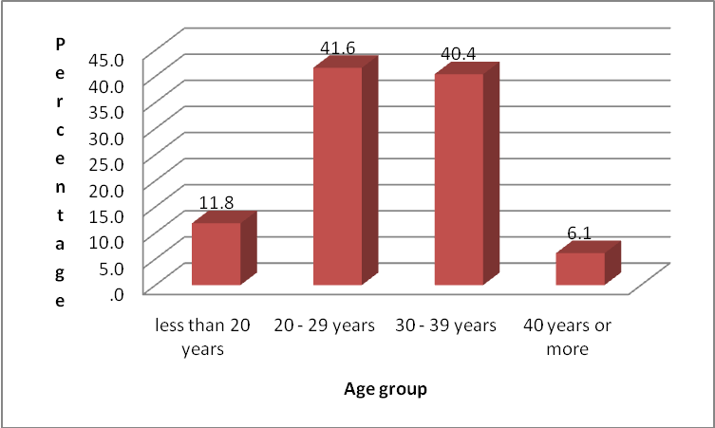
Figure 1: Age distribution of the abused women

4.1.4. Marital status of abuse women

Most of them were single 48.6 % (119) while 37.7 % (92) were married, 11% (27) divorced and 2.9 % (7) were separated.

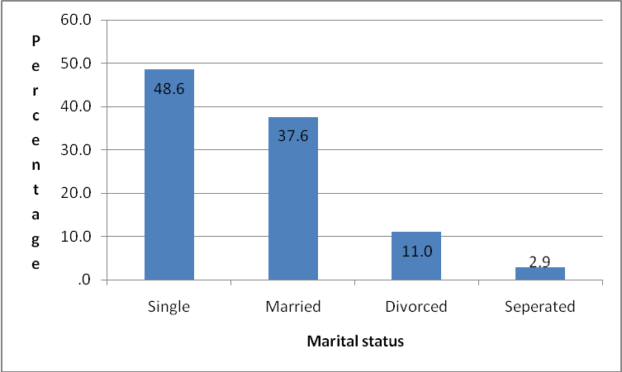

Figure 2: Marital status of the abused women

4.1.4. Place of residence

Only six cases came from low density suburbs and the rest were almost equally distributed across townships, rural areas and informal settlements.

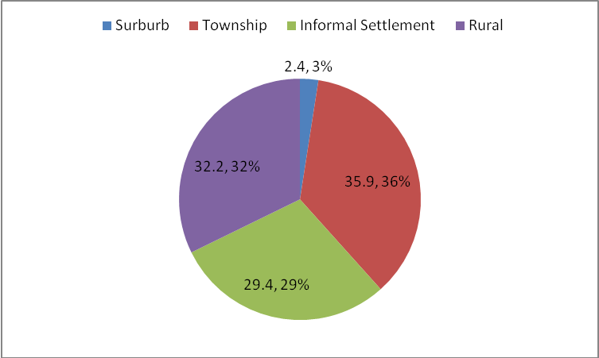

Figure 3: Place of residence of the abused women

4.1.5. Educational level of abused women

Only ten of the cases had no formal education while close to 82% (200) had at most a secondary school education and the rest 14.3% (35) had tertiary education.

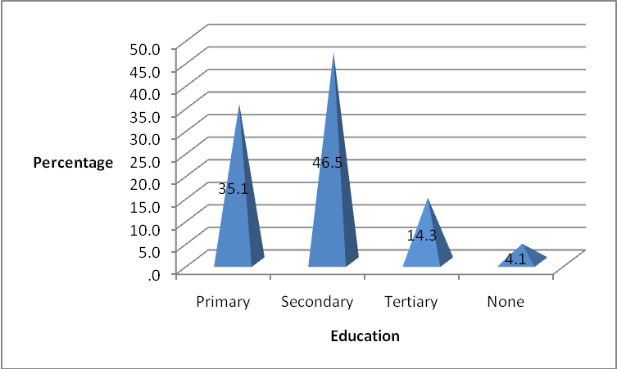
Figure 4: Educational level of abused women.

4.1.6. Employment status of the study sample

About 24% (59) of the cases were unemployed and 26.9% (66) were students. This gives a total of close to 50% (125) of cases who are economically inactive. The rest of the respondents were either in full time (15.1%) or in part time (33.9%) employment.

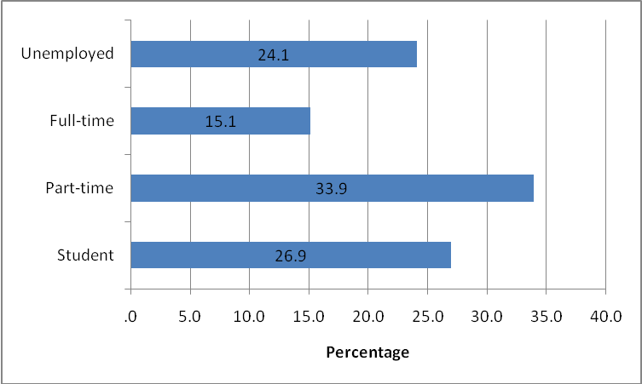
Figure 5: Employment status of the study sample.

4.1.7. Clinical Conditions and Characteristics

The same descriptive analysis carried out for the socio-demographic characteristics was also done for the clinical condition variables. The results are presented below.

4.1.7.1. Presentation of the abused women at the time of reporting

Most cases presented at the centre traumatized 51 %( 125), 24% (60) were injured followed by 13 % (32) confused while 8.6 %( 21) were reserved and 2.9% (7) Not well groomed.

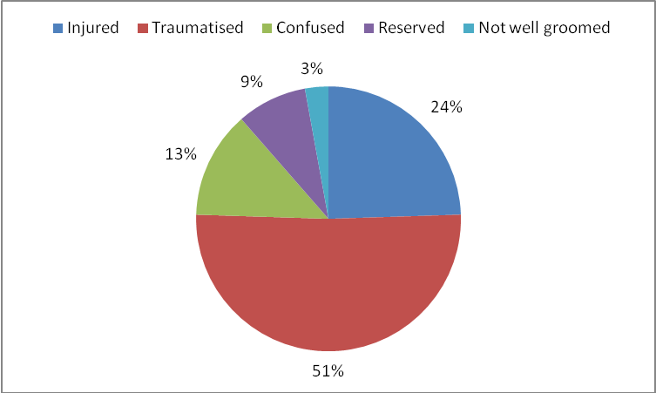
Figure 6: Presentation of the abuse women at the time of reporting.

4.1.8. Distribution of the Type of Abuse among the Women

The most common form of abuse was emotional 55.5 % followed by physical abuse at 31% while sexual abuse was 7.3. % and economical abuse was 6.1%

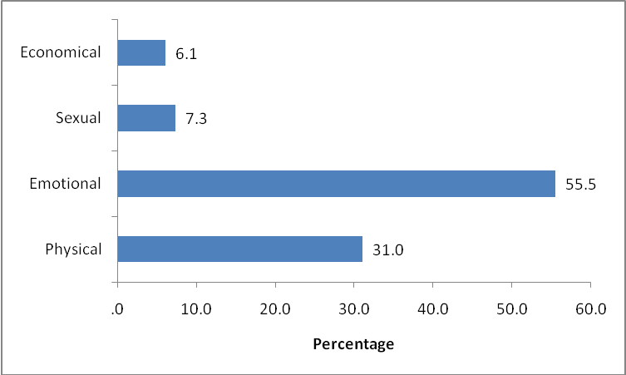
Figure 7: Distribution of types of abuse among the women

4.1.9. Substance Abuse

Over a quarter 35, 5% of them used tobacco, 10.2% used alcohol and 3.3. % used illicit drug while 53.1% did not use any form of substance

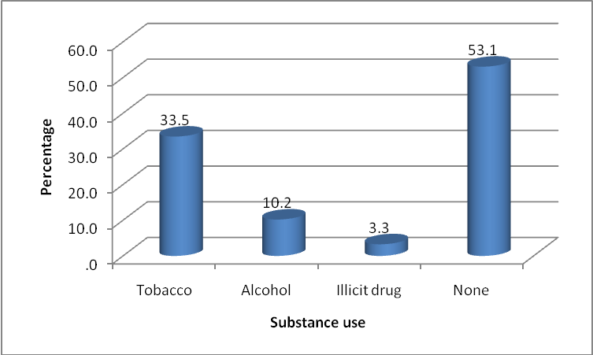
Figure 8: Substance used by the abused women

4.1.10. Personality Traits of the Abused Women

Less than 1% of the cases were found to be oversensitive while most 44.1% (108) were angry individuals. Stubborn cases were 25.7 % (63) and 15%1(37), were submissive while 14.3% (35) were aggressive.

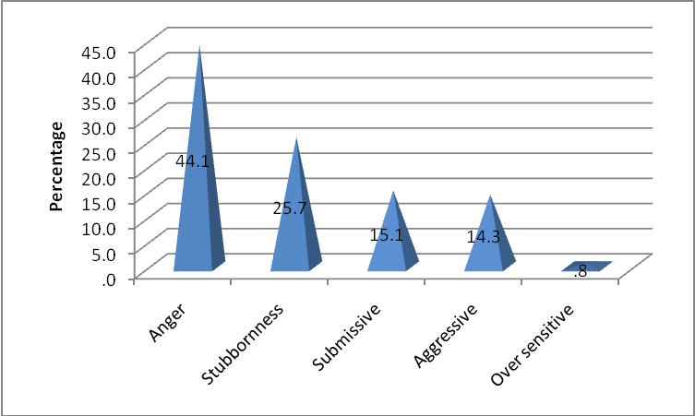
Figure 9: Personality trait of the abused women at the time of reporting.

4.1.11. Number of times women reported their Abuse

Of the 245 cases included in this study, about 55.9 % (137) had reported abuse only once and 26.5% (65) twice to five times while 17.6% (43) reported more than five times.

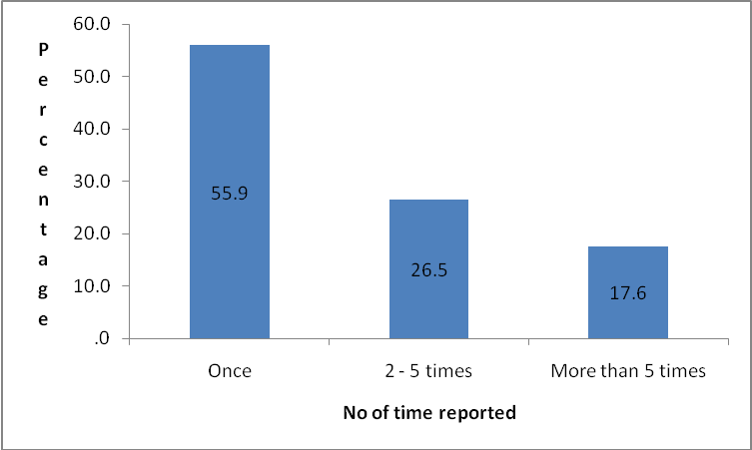

Figure 10: Number of times women reported their abuse.

4.1.12. Time of reporting abuse by the study sample

Majority of the women 80 % (195) reported their abuse during midweek while 20.4 % (50) of the women reported their abuse during month end.

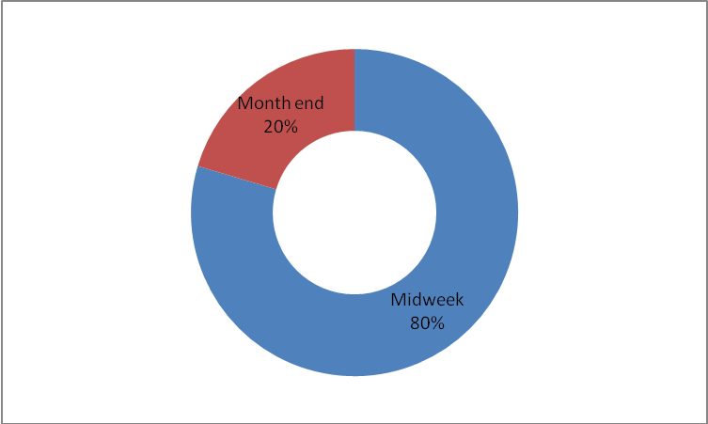
Figure 11: Time of reporting of abuse by the study sample.

4.1.12. Time of Reporting

The entire abused women100% (245) reported during the day.

 |  | Frequency | Percent | Valid Percent | Cumulative Percent
Valid | Day | 245 | 100.0 | 100.0 | 100.0
Table 10: Time of reporting

4.1.13. Obstetric Condition of the Women during Abuse

One-tenth 12% (29) of the women were abused during their pregnancy and other 25 % (62) during their menstruation period. 16 % (40) of the women were abused whilst breastfeeding and the rest 46.5 % (114) of the women presented at the centre without any obstetric history.

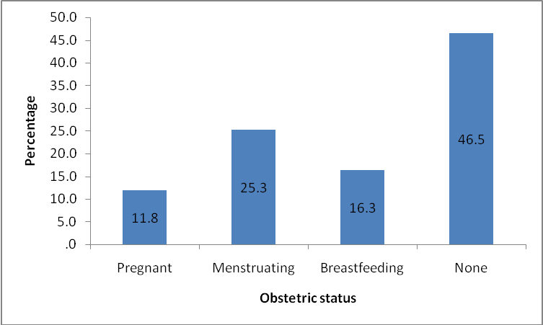
Figure 12: Obstetric conditions of the women during abuse.

4.1.14. Distribution of Disability of Women by Abuse

Because of abuse, almost a quarter 24% (59) of the women was physically disabled, 17% (42) psychiatric while 59 % of the women had no disabilities.

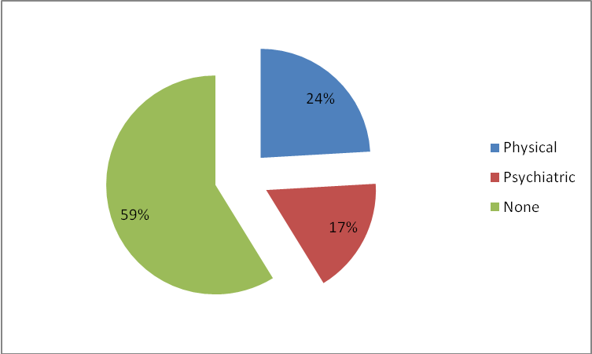
Figure 13: Distribution of disabilities of women by abuse.

4.1.15. No Children had Among Abused

Two thirds 66 % (102) of the women who had children between 1 and 4 were abused. 15.9 % (39) of the abused women had more than 5 children while 18% (44) had none.

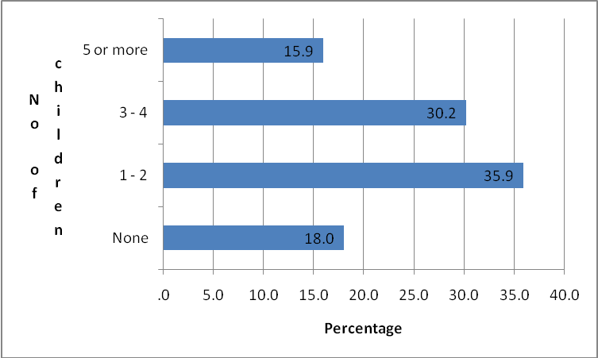
Figure 14: No of children had among the abused women.

4.1.14. Relationship between women and their Perpetrator

Most abuse was perpetrated by either husbands (37.1%) or partners (42.5%). These two perpetrator types accounted for close to 80% of the cases included in this study. 11.4% (28) of the abuse perpetrated by parent and 9 % (22) by other.

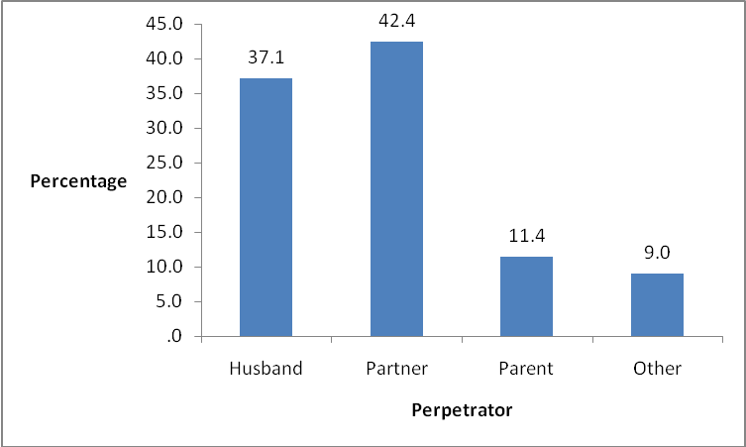

4.1.15. Distribution of the Occupation of the Perpetrator

Those who mentioned their perpetrators occupation, about a quarter 24% (58) of them were reverend. 6% of them were teachers while another 6% were police.

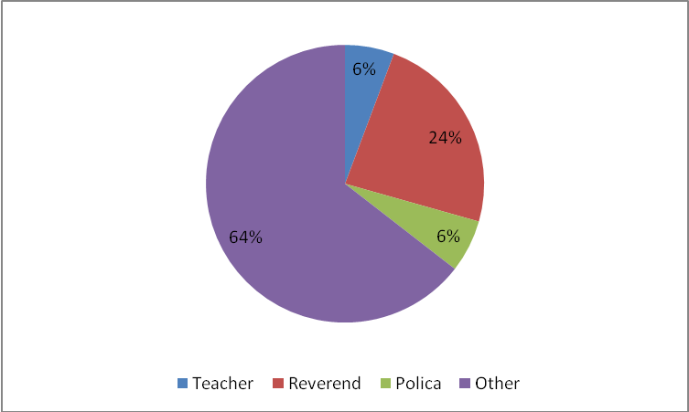
Figure 16: Distribution of the occupation of the perpetrator

CHAPTER FIVE

DISCUSSION, CONCLUSION AND RECOMMENDATIONS

5.1. INTRODUCTION

The purpose of the study was to examine characteristics of abused women, who visited Masonwabisane women support centre Butterworth Eastern Cape.

In this chapter the analyzed data is discussed under the following headings: demographic data which consisted of age, marital status, place of residence, educational status and employment status and clinical data which consisted of presentation at the centre, type of abuse, substance abuse, personality traits, frequency of reporting, period of reporting, time of reporting, obstetric status, disabilities, number of children relationship to the perpetrator and occupation of the perpetrator.

5.2. Discussion

Demographics and clinical data are clearly discussed here below.

5.2.1. Demographic Data

Age group

This study shows that the majority of respondents were under the age of 40 years and most of them 42% being between ages 20-29 years (figure 1). This is consistent with earlier findings that older women are less likely to report current experience of abuse than young women (Fermandes, 1997; McClusk, 2001?? This is not literature review). This appeared to apply in the study conducted at MSWC. Older women do not report abuse because of the financial dependency and security; even if abuse is identified by the neighbors they do not want to report it as they don’t want to interfere with other people’s business.

Marital status

Among the abused women most of them were single 49% while about 14% were either separated or divorced and the rest were married(figure 2). According to Renvoize, 2002 there are high numbers of women who are abused by their husband or spouses, and these women continue to think that situation will improve or normal because their partners live them, and therefore do not report this to officials. However this situation applies to Butterworth as most reported cases were single.

Place of residence
Only six cases came from low density suburbs and the rest were almost equally distributed across townships, rural areas and informal settlements (figure 3). This may not be the true reflection, because people living in the suburbs are educated, elite, reach and professional who may not report abuse because of their in society or community (researcher’s view)

Educational level of abused women
A look at educational level reveals that only 10 cases had no formal education, 82 % (200) had secondary education and 34% had tertiary education. This is in line with status inconsistency theories by ( Snow et al., 1998 ) which see violence as resulting from resource imbalance among family members where resources include both material and non material (such as education and prestige etc) assets. Even those educated up to secondary level are not good candidates for employment therefore they fall under the list of imbalanced resource (researcher’s opinion).

Employment status of the study sample

About 24% (59) of the cases was unemployed and 27 % (66) were students. This gives a total of close to 50% (125) of cases who are economically inactive. The rest of the respondents were either in full time (15 %) or in part time (34%) employed. These findings support what has been hypothesized in previous studies that women who are engaged in paid employment have more say over financial and other household matters than women who are not in active labour market (Malhotra and Matter, 1997).

5.2.2. CLINICAL DATA

Presentation at the centre
Most cases presented at the centre traumatized 51 % (125), some injured 24 % (60), confused 13 % (32), 8.6 % (21) reserved, while 13 % (32) confused. The findings are supported by what is said in VAW concerning the effect of domestic violence on women’s general health condition: has a serious consequence for women’s health and well being ranging from fatal and non fatal outcomes that include manifestations of mental, physical, and reproductive health outcomes and negative health behaviors (Heise et al., 1999)

Type of abuse among women

The study shows that the most common form of abuse was emotional 55.5%, followed by physical 31%, sexual 7.3% and economically 6.1% (figure 7). This is in line with what is said above by (Heise et al, .1999) on non fatal outcomes of violence against women.

Substance abuse

A look at substance abuse by abused women reveals that over 35.5% of them use tobacco, 10.2% alcohol and 3.3% illicit drug while 53.1% did not use any form of substance, and when asked about this tobacco use they reported that they use tobacco to comfort themselves and to relieve stress.

Personality traits of abused women

The results indicated that most of the respondents were angry 44.1%. Stubborn cases were 25.7% and 15 % were submissive while 14.3% were aggressive and only less than 1% oversensitive. Dulton (1992) believes that anger is most common among abused women. Anger is commonly directed to husband or boyfriend. This anger is prolonged and in some cases may be directed to society, police or family members for not helping when the victim is crying for help. According to Viano (1992) the wife that is abused is always ashamed, embarrassed, and angry about what is happening to her.

Number of times women reported abuse

The study shows that of the 245 cases included in the study 55.9% has reported abuse only once, 26.5% twice to five times while 17.6% reported more than five times.

Time of reporting abuse by the study sample

A look at the time of reporting reveals that majority of women 80% reported their abuse during mid week while 20.4% of the women reported during month end. (figure11). This may due to the operating hours of the center as it operates only during week days.

Time of reporting

The study shows that the entire women 100% reported during the day. The centre operates only during the day from 08h00 to 16h30.This may not be a true picture as most instances of abuse occur during the night. Some of the victims may feel it is no longer necessary to report abuse the following day (researcher’s view).

Obstetric condition of women during the abuse

The results indicated that one – tenth of the women 12% were abused during their pregnancy and 25% during their menstruation period, 16% abused whilst breastfeeding and the rest 46.5% presented at the centre without any obstetric history. Several review of relevant literature (Heise et al., 1999; Campbell, 2002) emphasizes the linkage between the experience of domestic violence and both fatal and nonfatal outcomes for women and their children. Fatal outcome related to domestic violence for women can result directly through homicide or indirectly through suicide and maternal or AIDS related mortality. Non fatal outcomes include manifestations of mental, physical, and reproductive health outcomes, and negative health behaviours (Heise et al., 1999). Abused women’s reproductive health is also compromised through much high rates of gynaecological problems, HIV, sexually transmitted infections (STIs),miscarriages, abortions, unwanted pregnancy and low birth weight (Campbell 2002).

Disability of women by abuse

The study shows that because of abuse, almost a quarter 24% (59) of the women were temporary physically disabled and 17% (42) psychiatric while 59 % of the women had no disabilities.

Number of children among abused women

A look at the number of children among abused women reveals that two thirds 66 %( 102) of the women who had 1 and 4 children were abused. 15.9 % (39) of the abused women had more than 5 children while 18% (44) had none. Several studies indicate that the risk of experiencing violence is positively associated with women’s number of children (Ellsberg, 1999; Martin et al., 1999). The relationship between violence and the number of children a woman has borne can be conceptualized such that when there are more children in the household, there is less income per capita, insufficient resources may lead to exacerbated level of stress for the head of the household, which may lead to violence in some instances, hence the more the children the greater the likelihood of violence (Martin et al., 1999). According to multi- country domestic violence study results shows that women with no children have the lowest rates of ever – experience of violence, and in most countries women with five or more children have the highest of ever – experience of violence.

Relationship between women and their perpetrator

The study shows that most abuse was perpetrated by either husbands (37.1%) or partners (42.5%). These two perpetrator types accounted for close to 80% of the cases included in this study. 11.4% % of the abuse perpetrated by parent and 9 % by other.

The occupation of the perpetrator

The results indicated that those who mentioned their perpetrators occupation, about a quarter 24% (58) of them were ministers of religions 6% of them were teachers while another 6% were police.

5.4. Recommendations

Based on the findings of the study the section below tabulates the recommendations.

Policy Makers

“The struggle to end violence against women in South Africa is central to our National liberation. South Africans cannot be free as long as women are vulnerable to abuse, rape and murder. Violence against women must be fought at all levels.” Address by Mr. Andries Nel, MP, Deputy Minister of Justice and Constitutional Development at a Conference on Africa sharing experiences and solutions on sexual and gender based violence management, Cape Town, 10 November 2009.

Government especially Department of Health as the first contact for injured victims should be fully involved in domestic violence e.g. establish a directorate for domestic violence.

There is a need to accelerate poverty alleviation programs in Mnquma local municipality and similar areas. Programs that will empower women with skills so that they can enter the job market should be pursued. The government with the help of the private sector and international donors need to come up with programs that will empower women with skills and employment opportunities. A poverty alleviation program, which will result in women being able to have sustainable jobs, is urgently needed in Mnquma Local Municipality.
The response to domestic violence is typically a combined effort between law enforcement, social services and health care. All these services play an important part in bringing domestic violence into public view.
Social norms that support and condone violence need to be changed. Awareness campaigns family and community level to overcome barriers to women seeking formal help.
Medical professionals working in areas such as casualty, HIV/AIDS, maternal health, and mental health should be trained to identify domestic violence.
A special trauma unit for the victims should be established for counselling, treatment and rehabilitation.

It could benefit the victim if the women support centre in Butterworth is accessible to victims for 24 hours.

5.5. Conclusion

The following characteristics were observed from women who visited Masonwabisane women support centre Butterworth, most women between 20-29 years of age were single they were either having steady relationships co-habiting. Most of them were staying in partner’s house or flat. Some indicated that children they have were not from the same father. Most of them came from townships and were economically inactive. It was evident from data analysis that most of them had low level of education (82 % secondary education) and they struggle to get employment. Another characteristic was that 66 % of cases were still students and therefore depended on their partners for financial support, which in some cases were elderly men. Most of them presented traumatized at the centre and the common form of abuse experienced was emotional abuse. Most of the abused women were found angry. Tobacco use by the abused women was also common and when asked about this tobacco use they reported that they use tobacco to comfort themselves and to relieve stress. Most of them reported abuse at the centre during the weekdays and working hours. This could have an impact on statistics of women abuse as some women are abused by their partners or husbands during the night or weekend, some of them may feel it is no longer necessary to report abuse the following day or following week.
It was also evident that there was a relationship between obstetric status and abuse as some of them were abused during their menstrual period, others during breastfeeding and also during pregnancy. The researcher associated this with social and cultural practises where women cannot have sex during these instances. To some extent others were so abused that they got severe injuries leading to temporary disability. The social and economic costs of violence against women have detrimental effects in their communities and society in general. Abused women suffer isolation, inability to work, lack of self confidence, lack of participation in societal activities, and limited ability to care for themselves and their children.

References

Abraham, M. 2000. Speaking the unspeakable: Marital Violence among South Asian Immigrants in the United States. New Brunnswick, NJ: Rutgers University Press.

Asling-Monemi, K., R. Pena, M.C. Ellsberg, and L.A. Persson. 2003. Violence
against women increases the risk of infant and child mortality: A case-referent study
in Nicaragua. Bulletin of the World Health Organization 81(1): 10-18.

Barnett OW and Parrin CL, (2005) Family Violence Across the Lifespan, Cambridge Press

Bohn, D.K. (1990). Domestic violence and pregnancy: Implication for practice.

Bott, Sarah, Andrew Morrison and Mary Ellsberg, Preventing and Responding to Violence against women in Middle-and Low-Income Countries: A Global Review and Analysis, World Bank Policy Research Working Paper 3618, the World Bank, Washington, DC, June, 2005

Buzawa E.S. & Buzawa, C.S., 2002, Domestic violence the criminal justice response. London: Oxford , uac.utoledo.edu/Publications/Davis-Ventura-domestic-violence

Campbell, J.C. 2002, Health consequences of intimate partner violence. Lancet 359:
1331-1336.

David A, 1990, Domestic Violence: One of the key social challenges, New York

Dobash, RP and Dobash RE, 1992, The myths of sexual symmetry in marital violence
Social Problems, Vol 39 No1, 1 February 1992

Dulton, M.A. 1992. Empowerment and healing the battered women. New York: Prantice.

Flitcraft, A.& Stark, E. 1992. Women at risk of domestic violence and women’s health. New York: Library

Fernandez, M. 1997. Domestic violence by extended family members in India. Journal
of Interpersonal Violence 12(3): 433-455.

Friedman W, 2003, Examining the Effects of Domestic Violence Policies and Social Norms, Georgia

Gillespie, T. &Lupton C. (2002). Working with violence. New Jersey: Practice.

Gelles, R.J. 1993. Through a sociological lens: Social structure and family violence.
In R.J. Gelles and D.R. Loseke (eds.), Current controversies on family violence. Newbury, Park, California: Sage Publications.

Hutchings, M 1998, implications of violence between intimate partners for children, Cambridge university press

Heise, Lori, Mary Ellsberg and Megan Gottemoeller, 1999, “Ending Violence against Women”, Population Reports, Vol. XXVII, Number 4, Series L, Number 11, (available at www.infoforhealth.org.pr/111/violence.pdf)

Integrated Development Plan 2009/2010 Butterworth: Mnquma local service municipality.

Jejeebhoy, S.J. 1998. Associations between wife-beating and fetal and infant death:
Impressions from a survey in rural India. Studies in Family Planning 29(3): 300-308.

Johan, S, 1994, Violence and Gender: The Case for Peace Studies, New York

Kalmuss, D. 1984. The intergenerational transfer of marital aggression. Journal of
Marriage and the Family 46: 11-19.

Karmen A, 1990, Crime Victims: An introduction to victimiology, New York

Koos MM and Goodman LA, (1994), The development roots of borderline personality in early attachment, New York Free

Kishor, S. 2000. Empowerment of women in Egypt and links to the survival and
health of their infants. In H.B. Presser, and G. Sen (eds.), Women’s empowerment and
demographic processes: Moving beyond Cairo. New York: Oxford University Press.

Kirkwood, K. (1999). Learning abusive partner. Pacific Groove: Brook’s & Cole.

Kleint, G, (2001) Women secretes about domestic violence. Pacific Groove: Brook’s & Cole.

Malhotra, A., and M. Mather. 1997. Do schooling and work empower women in
developing countries? The case of Sri Lanka. Sociological Forum 12(4): 599-630.

Martin, S.L., A.O. Tsui, K. Maitra, and R. Marinshaw. 1999. Domestic violence in
northern India. American Journal of Epidemiology 150(4): 417-426.

Mathew, T. 1996, Work placement report on domestic violence, Thesis in partial requirement for MSc in applied Psychology, University of Colombo, Sri Lanka

McClusky, L. 2001. Here, our culture is hard: Stories of domestic violence from a Mayan
community in Belize. Austin, Texas: University of Texas Press

Manor, O. (1997). Family work in action. New York: Lexicon.

Morrison JE and Hines DC, 1998, Psychological effects of partner abuse against men, Cambridge University Press

National Coalition Against Domestic Violence, 1989, The impact of sexual abuse

Reid, J.L. (2002) Family problem solving. New York: Practice.

Renvoize S, (2002) Perspective on female sex offending: A Cultural Denial, New York

Roy, M. (1992) Battered women a psychological study of domestic violence. New York Free.

Seltzer, J.A., and D. Kalmuss. 1988. Socialization and stress explanations for spousal
abuse. Social Forces 67(2): 473-491.

Sithunda S. and Lolwana L. (14 March 2007) Izwilamakhosikazi (Radio program). Unitra Community Radio.

Snow DL and Swan S, 1998, Differences amongst women who use intimate relationships, vaw.sagepub.com

Taylor JY and Steward F, 2002, The voices of domestic violence survivors, Oxford University Press
Viano E C 1992 ‘Violence among intimates: major issues and approaches in intimate violence: interdisciplinary perspectives’ Hemisphere Publishing Corporation USA

World Health Organization. 2004. Gender-based violence Web site:
http://www.who.int/gender/violence/en/, February

APPENDICES

APPENDIX A

DATA EXTRACTION TOOL

Number | Variable | Victim
 | Demographic Data
1. | Age(Years)
 | Less than 19
 | 20-29
 | 30-39
 | More than 40
2. | Marital Status
 | Single
 | Married
 | Divorced
 | Separated
3. | Place
 | Suburb
 | Township
 | Informal settlement
 | Rural
4. | Education (Highest completed)
 | Primary
 | Secondary
 | Tertiary
 | No formal education
5. | Employment Status
 | Student
 | Par time
 | Full employment
 | Unemployed
 | Clinical Data
6. | Presentation at the Centre
 | Injured
 | Traumatised
 | Confused
 | Reserved
 | Not well groomed
7. | Type of abuse
 | Physical
 | Emotional
 | Sexual
 | Economical
8. | Substance Use
 | Tobacco
 | Alcohol
 | Illicit drugs
 | None use
9. | Personality Traits
 | Anger
 | Stubborn
 | Submissive
 | Aggressive
 | Oversensitivity
10. | Frequency of Reporting
 | Once
 | Less than five times
 | More than five times
11. | Period of Reporting
 | Mid week
 | Week end
 | Month end
12. | Time of Reporting
 | Day
 | Night
13. | Obstetric Status
 | Pregnant
 | Menstruating
 | Breastfeeding
 | No obstetric history
14. | Disability
 | Physical
 | Intellectual
 | Psychiatric
 | No disability
15. | Number of Children
 | None
 | 1-2
 | 3-4
 | More than 4
16. | Relationship with the Perpetrator
 | Husband
 | Partner
 | Parent
 | Other
17. | Occupation of the Perpetrator
 | Teacher
 | Reverend
 | Police
 | Other

APPENDIX B
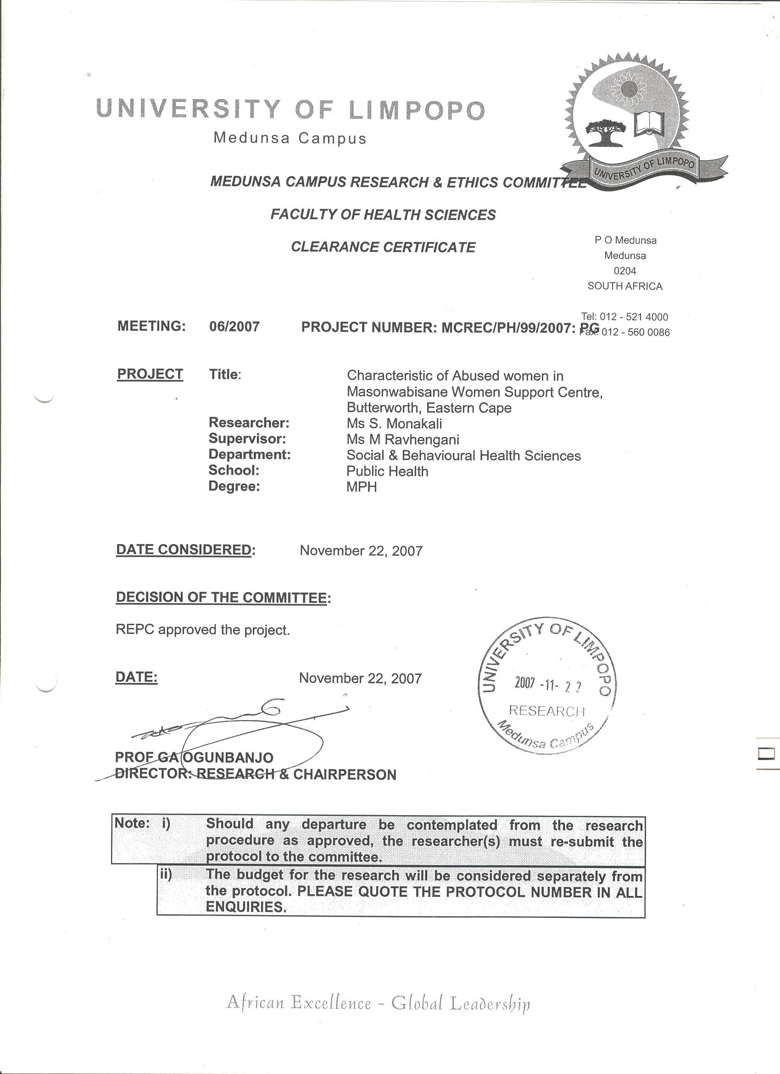

APPENDIX C- PERMISSION LETTER FROM EASTERN CAPE DOH
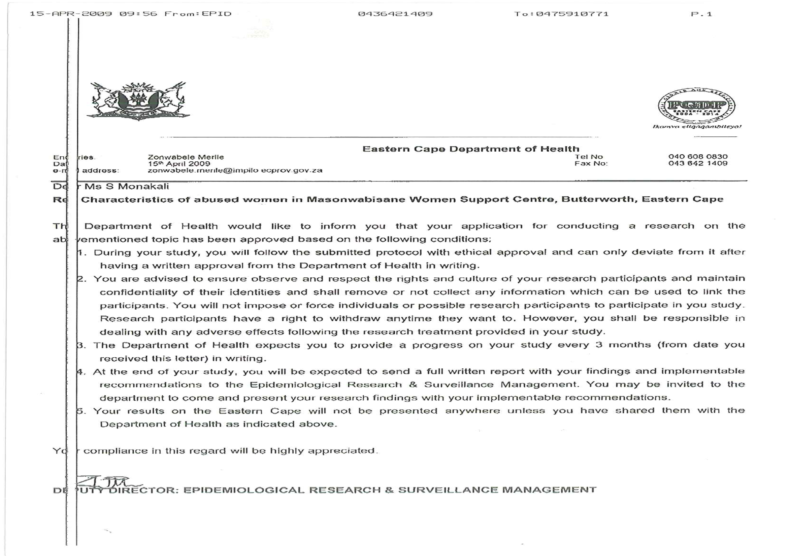

APPENDIX D
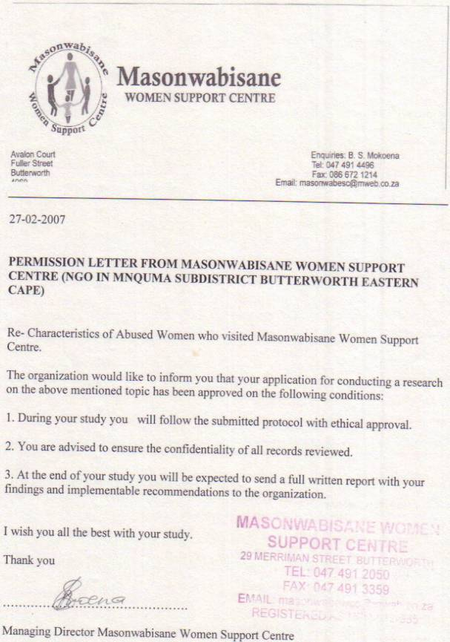

APPENDIX E
